#Sentiment anaysis on "Noise colourfit watch" reviews in amazon

import requests # Importing requests to extract content from a url

from bs4 import BeautifulSoup as bs # Beautifulsoup is for web scrapping...used to scrap specific content

import re

#pip install wordcloud

import matplotlib.pyplot as plt

from wordcloud import WordCloud

# creating empty reviews list

noise_reviews=[]

for i in range(1,21):

ip=[]

url="https://www.amazon.in/Noise-ColorFit-Monitor-Personalised-Waterproof/product-reviews/B08PZ96F8V/ref=cm_cr_getr_d_paging_btm_next_2?ie=UTF8&reviewerType=all_reviews&pageNumber="+str(i)

response = requests.get(url)

soup = bs(response.content,"html.parser")# creating soup object to iterate over the extracted content

reviews = soup.find_all("span",attrs={"class","a-size-base review-text review-text-content"})# Extracting the content under specific tags

for i in range(len(reviews)):

ip.append(reviews[i].text)

noise_reviews=noise_reviews+ip # adding the reviews of one page to empty list which in future contains all the reviews

# writng reviews in a text file

with open("noise_py.txt","w",encoding='utf8') as output:

output.write(str(noise_reviews))

# Joinining all the reviews into single paragraph

ip_rev_string = " ".join(noise_reviews)

import nltk

#from nltk.corpus import stopwords

# Removing unwanted symbols incase if exists

ip_rev_string = re.sub("[^A-Za-z" "]+"," ", ip_rev_string).lower()

ip_rev_string = re.sub("[0-9" "]+"," ", ip_rev_string)

# words that contained in iphone XR reviews

ip_reviews_words = ip_rev_string.split(" ")

#TFIDF

from sklearn.feature_extraction.text import TfidfVectorizer

vectorizer = TfidfVectorizer(ip_reviews_words, use_idf=True,ngram_range=(1, 3))

X = vectorizer.fit_transform(ip_reviews_words)

with open("C:/Users/USER/Desktop/Data Mining/Text_Mining/stop.txt","r") as sw:

stop_words = sw.read()

stop_words = stop_words.split("\n")

stop_words.extend(["noise","watch","product","good","app"])

ip_reviews_words = [w for w in ip_reviews_words if not w in stop_words]

# Joinining all the reviews into single paragraph

ip_rev_string = " ".join(ip_reviews_words)

# WordCloud can be performed on the string inputs.

# Corpus level word cloud

wordcloud_ip = WordCloud(

background_color='White',

width=1800,

height=1400

).generate(ip_rev_string)

plt.imshow(wordcloud_ip)

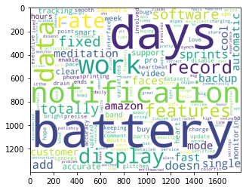

# positive words # Choose the path for +ve words stored in system

with open("C:/Users/USER/Desktop/Data Mining/Text_Mining/positive-words.txt","r") as pos:

poswords = pos.read().split("\n")

# Positive word cloud

# Choosing the only words which are present in positive words

ip_pos_in_pos = " ".join ([w for w in ip_reviews_words if w in poswords])

wordcloud_pos_in_pos = WordCloud(

background_color='White',

width=1800,

height=1400

).generate(ip_pos_in_pos)

plt.figure(2)

plt.imshow(wordcloud_pos_in_pos)

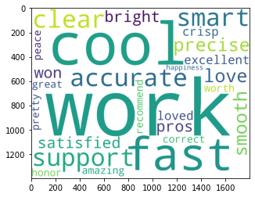

# negative words Choose path for -ve words stored in system

with open("C:/Users/USER/Desktop/Data Mining/Text_Mining/negative-words.txt", "r") as neg:

negwords = neg.read().split("\n")

# negative word cloud

# Choosing the only words which are present in negwords

ip_neg_in_neg = " ".join ([w for w in ip_reviews_words if w in negwords])

wordcloud_neg_in_neg = WordCloud(

background_color='black',

width=1800,

height=1400

).generate(ip_neg_in_neg)

plt.figure(3)

plt.imshow(wordcloud_neg_in_neg)

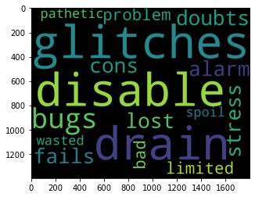

# wordcloud with bigram

nltk.download('punkt')

from wordcloud import WordCloud, STOPWORDS

WNL = nltk.WordNetLemmatizer()

# Lowercase and tokenize

text = ip_rev_string.lower()

# Remove single quote early since it causes problems with the tokenizer.

text = text.replace("'", "")

tokens = nltk.word_tokenize(text)

text1 = nltk.Text(tokens)

# Remove extra chars and remove stop words.

text_content = [''.join(re.split("[ .,;:!?‘’``''@#$%^_&*()<>{}~\n\t\\\-]", word)) for word in text1]

# Create a set of stopwords

stopwords_wc = set(STOPWORDS)

customised_words = ['price', 'great'] # If you want to remove any particular word form text which does not contribute much in meaning

new_stopwords = stopwords_wc.union(customised_words)

# Remove stop words

text_content = [word for word in text_content if word not in new_stopwords]

# Take only non-empty entries

text_content = [s for s in text_content if len(s) != 0]

# Best to get the lemmas of each word to reduce the number of similar words

text_content = [WNL.lemmatize(t) for t in text_content]

nltk_tokens = nltk.word_tokenize(text)

bigrams_list = list(nltk.bigrams(text_content))

print(bigrams_list)

dictionary2 = [' '.join(tup) for tup in bigrams_list]

print (dictionary2)

# Using count vectoriser to view the frequency of bigrams

from sklearn.feature_extraction.text import CountVectorizer

vectorizer = CountVectorizer(ngram_range=(2, 2))

bag_of_words = vectorizer.fit_transform(dictionary2)

vectorizer.vocabulary_

sum_words = bag_of_words.sum(axis=0)

words_freq = [(word, sum_words[0, idx]) for word, idx in vectorizer.vocabulary_.items()]

words_freq =sorted(words_freq, key = lambda x: x[1], reverse=True)

print(words_freq[:100])

# Generating wordcloud

words_dict = dict(words_freq)

WC_height = 1000

WC_width = 1500

WC_max_words = 200

wordCloud = WordCloud(max_words=WC_max_words, height=WC_height, width=WC_width, stopwords=new_stopwords)

wordCloud.generate_from_frequencies(words_dict)

plt.figure(4)

plt.title('Most frequently occurring bigrams connected by same colour and font size')

plt.imshow(wordCloud, interpolation='bilinear')

plt.axis("off")

plt.show()

